NAME: SHAIK MOHAMMAD IRFAN
REG NO :192472190
COURSE CODE : ITA1416
COURSE NAME :EHICAL HACKING

- Ping:

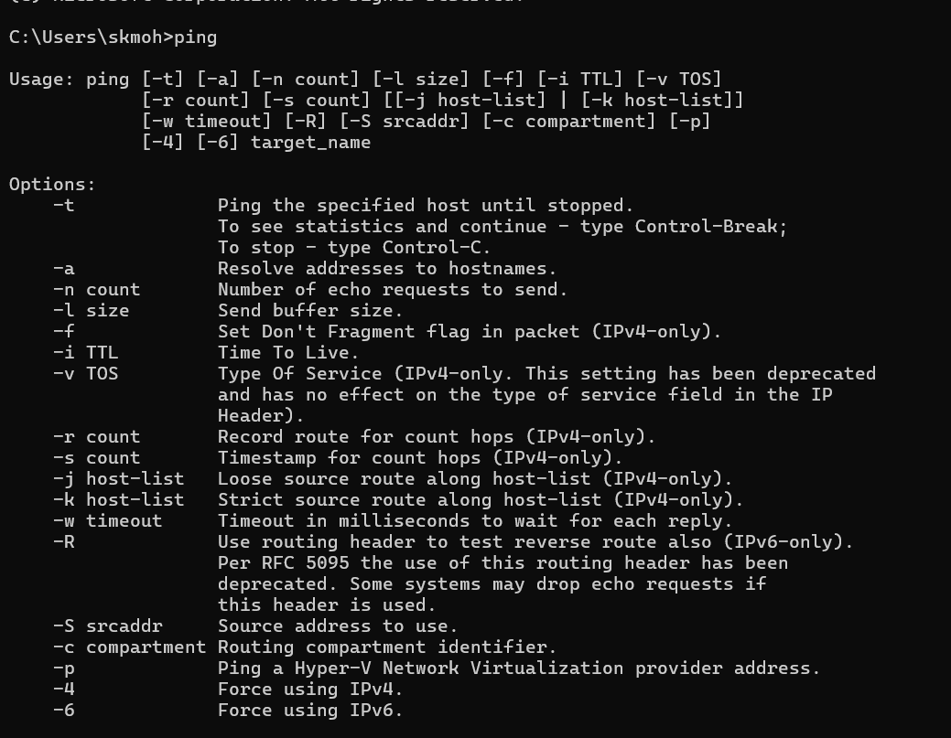

- Netstet:

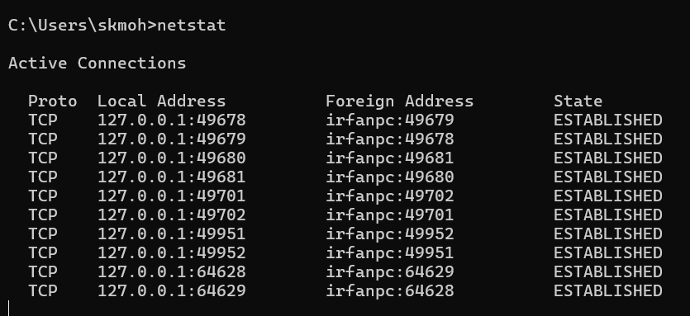
3. tracert
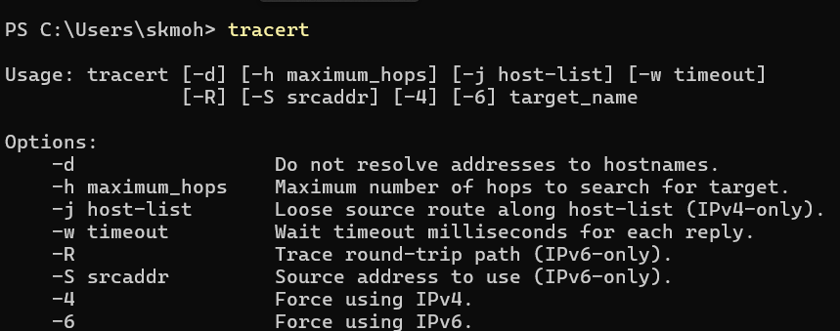

4.nslookup
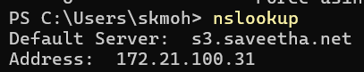

5. pathping
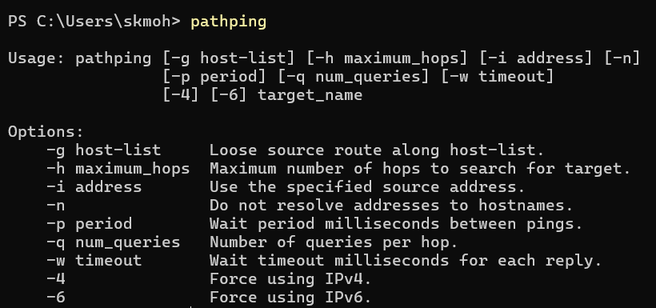

6.ipcongfig

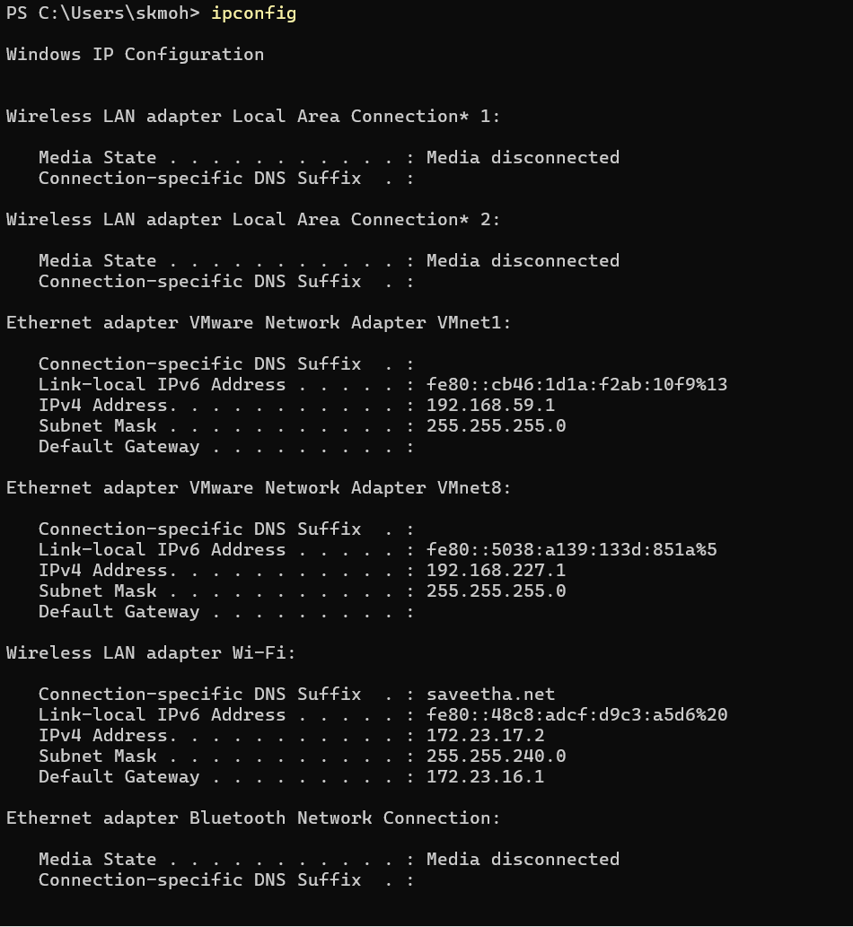

7.route
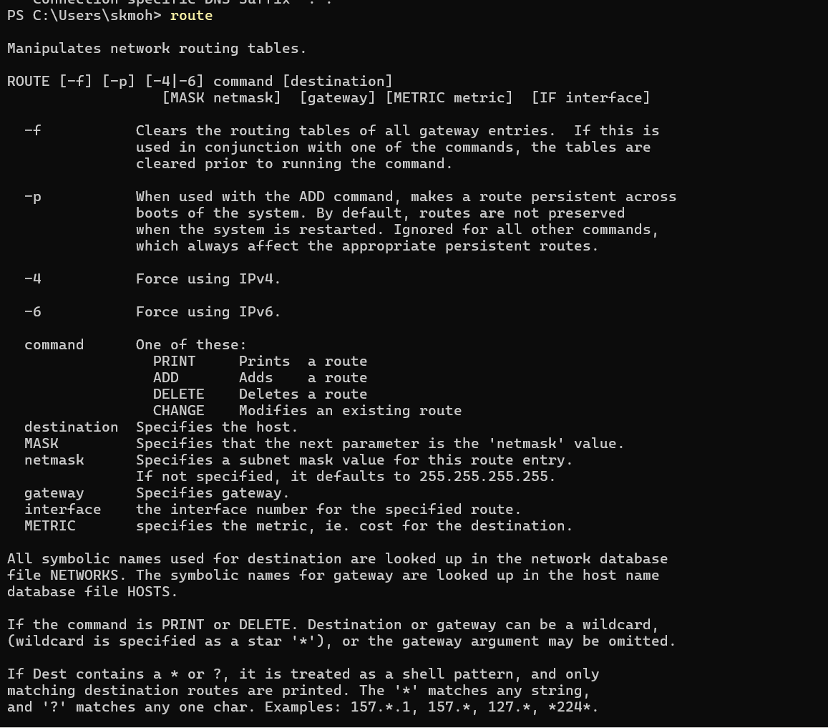

8.arp

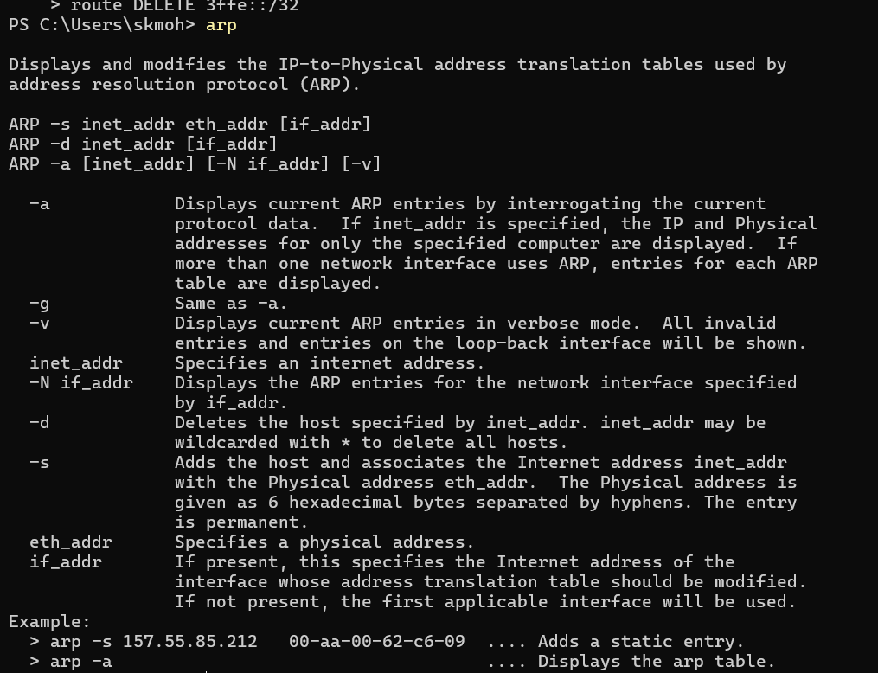

9. hostname
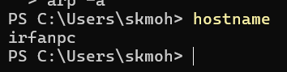

- Getmac
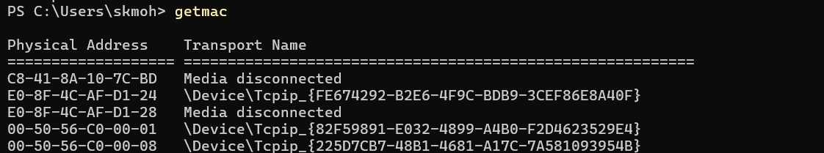

- Ssh
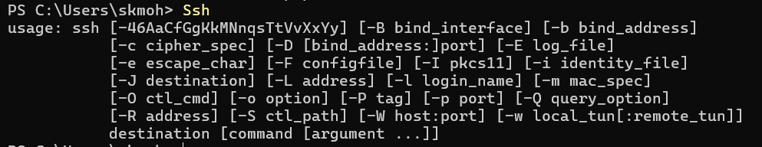

- Netsh
- netsh interface ip show config

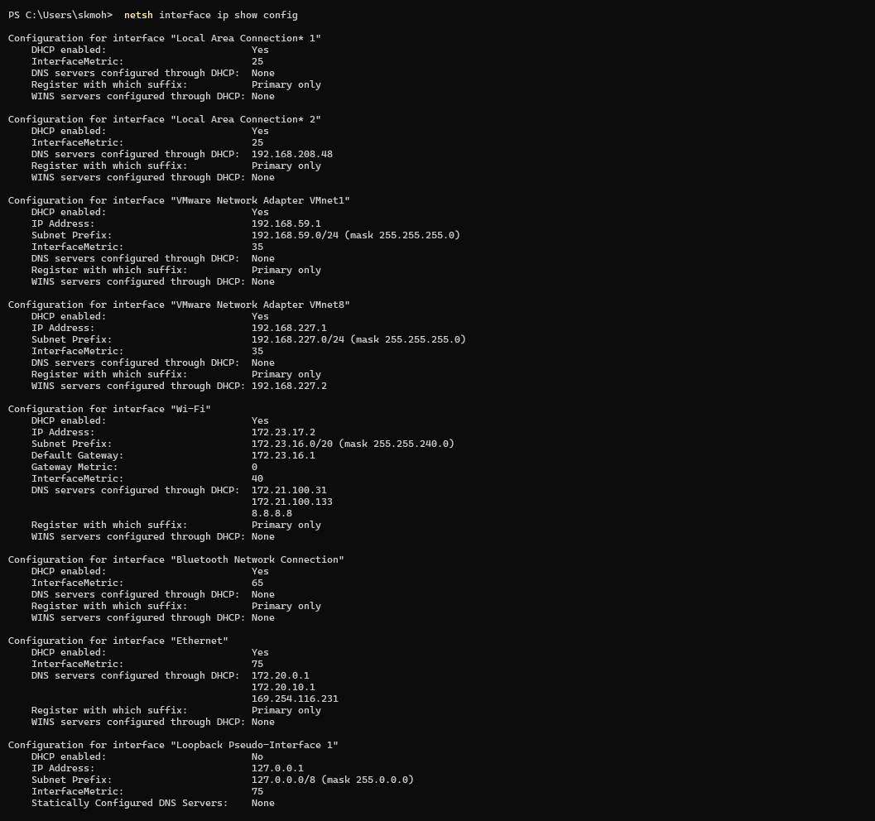

- netsh interface show interface

- netsh wlan show profiles
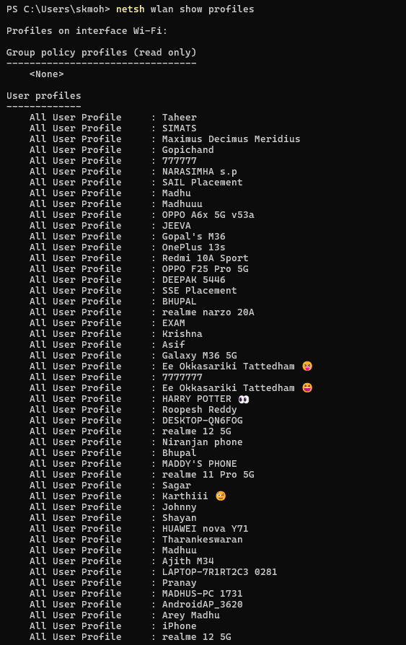
- netsh wlan show profile name="EXAM" key=clear
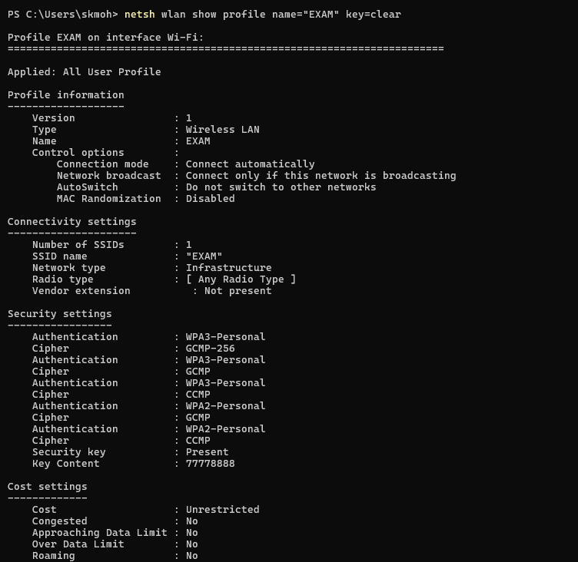

- Scp

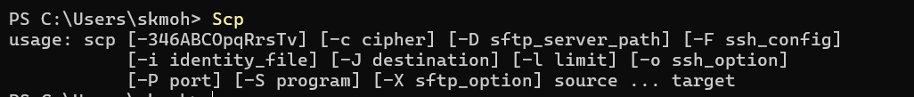

14.Getmac

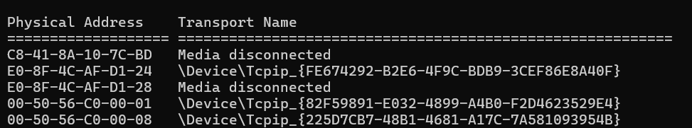

15 . Arp

